**Cell Theory Timeline**

**CELL THEORY HISTORICAL TIMELINE ACTIVITY**

p. 70-71

* List a few of the characteristics the following people have made to science
* List the Dates of the contributions that these people have made
* Robert Hooke:
* Hans & Zacharias Janssen:
* Anton van Leeuwenhoek:
* Matthias Schleiden:
* Theodor Schwann:
* Rudolph Virchow:

**\*\*\*Create a Timeline showing the chronological order of these scientists and their contributions. You will first put your information on Inventor Cards and then create your timeline. Here is what should be on the Timeline***ALL 6 INVENTORS ARE ON THE TIMELINE**

* **Label the time line with dates of the above Scientists discoveries (on the inventor card)**
* **The earliest date should be on the left of the timeline and the most recent date should be on the right**
* **Label each date with corresponding scientist's name & contribution(s) in an organized and legible manner**
* **Be sure your spacing shows a reasonable approximation of the amount of time that elapsed between dates**

**Questions to Answer**

1. What theory did these scientists provide evidence for?

Cell Theory

1. What instrument was necessary before the cell theory could be developed?

Compound microscope

1. Which 3 scientists directly contributed evidence for the cell theory?
2. __Schleiden ________________________
3. __Schwann_________________________
4. __Virchow__________________________
5. How did the earlier scientists and their contributions directly affect the discoveries of later scientists (see #2)? For example what had to come first? Janssen invented the compound microscope, Hooke first identified the cell, and Leeuwenhoek made better lenses
6. List the 3 Parts of the Cell Theory:
   1. All organisms are made of cells. ­­­­­­­­­
   2. All existing cells are produced by other living cells.
   3. The cell is the most basic unit of life.

**Inventor Cards**

**Date:** 1838

**Inventor: Matthias Schleiden**

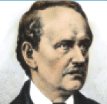

**Description: He was the first to note that plants are made of cells.**

**Date:** 1674

**Inventor: Anton van Leeuwenhoek**

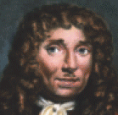

**Description: Because he made better lenses he observed cells in greater detail. Observed living cells; called some 'animalcules' .**

**Date:** 1665

**Inventor: Robert Hooke**

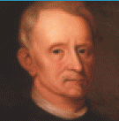

**Description: He looked at a thin slice of cork (oak cork) through a compound microscope and observed tiny, hollow, roomlike structures and called these structures 'cells'.**

**Date:**  1855

**Inventor: Rudolf Virchow**

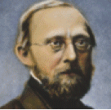

**Description: He proposed that all cells come from other cells.**

**Date:** 1839

**Inventor: Theodor Schwann**

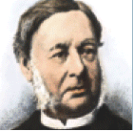

**Description: He discovered that animal parts are made of cells and concluded that all living things are made of cells.**

**Date:** ____Late 1500’s___

**Inventor: Hans and Zacharias Janssen**



**Description: Father and Son Dutch eyeglass makers invented the compound microscope**

**Date:** 1845

**Inventor: Carl Heinrich Braun**

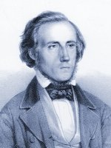

**Description: Carl Heinrich Braun reworks the cell theory, calling cells the basic unit of life.**

**Date:** 1840

**Inventor: Albrecht von Roelliker**

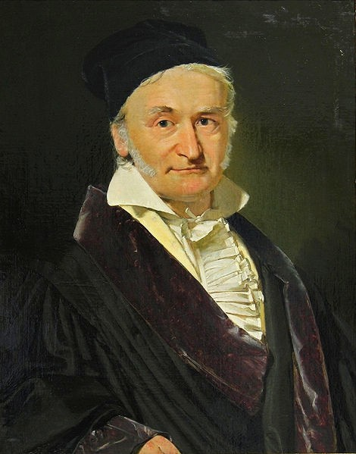

**Description: Where does life come from was discovered by Albrecht von Roelliker. He discovered that sperm and eggs are also cells.**

**Date:** 1833

**Inventor: Robert Brown**

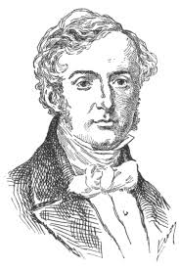

**Description: The center of the cell seen by Robert Brown, an English botanist. He discovered the nucleus in plant cells.**